IZZA IQBAL, REHAB GUL
AI PROJECT REPORT
B23F0317AI119, B23F0405AI126
BSAI-RED

Project Proposal: Pathfinding Visualizer

1. Title
Pathfinding Visualizer Using Pygame

2. Abstract
This project involves the development of a graphical application called the Pathfinding Visualizer using Python and the Pygame library. The tool demonstrates various pathfinding algorithms including A*, Breadth-First Search (BFS), and Depth-First Search (DFS). It allows users to interactively set start and end points, create barriers, and visualize the pathfinding process in real-time.

3. Introduction
Pathfinding algorithms are critical in a wide range of computer science applications, such as robotics, games, and network routing. Visualizing how these algorithms work enhances the learning experience and provides a deeper understanding of their behavior and efficiency.
This project uses Python's Pygame library to create a grid-based GUI that visualizes how different algorithms navigate through a maze to find the shortest path from a start node to an end node.

4. Objectives
- Implement a user-friendly GUI to visualize pathfinding algorithms.
- Support multiple algorithms: A*, BFS, DFS.
- Allow users to place and remove obstacles, and define start/end points.
- Show the progression of the algorithms in real-time.

5. Tools and Technologies
- Programming Language: Python 3.12.4
- Library: Pygame 2.6.1 (SDL 2.28.4)
- IDE: VS Code / PyCharm / Any Python-supported IDE

6. System Design
  - Grid System: The screen is divided into a 50x50 grid where each cell represents a node.
  - Node Class: Represents each cell with attributes like position, color, and neighbors.
  - Algorithms:
  - A* uses heuristics to find the optimal path.
  - BFS explores the shortest path layer by layer.
  - DFS explores as far as possible before backtracking.
  - Event Handling: Mouse and keyboard inputs are used for placing/removing barriers and running algorithms.

7. Implementation
- Initialization of Pygame and setup of the display window.
- Creation of Node class with methods to define state (start, end, barrier, etc.).
- Functions to handle user input and grid drawing.
- Implementation of A*, BFS, and DFS algorithms.
- Main loop to manage user interaction and visualize pathfinding process.

8. Features
  - Click to place start, end, and barriers.
  - Press 'A' to run A* algorithm.
  - Press 'B' to run BFS.
  - Press 'D' to run DFS.
  - Press 'C' to clear the grid.

9. Results
The application successfully visualizes all three algorithms. Users can clearly observe how different strategies are used by each algorithm to reach the destination. A* is found to be the most efficient in most cases due to its heuristic-based approach.
A* Search:
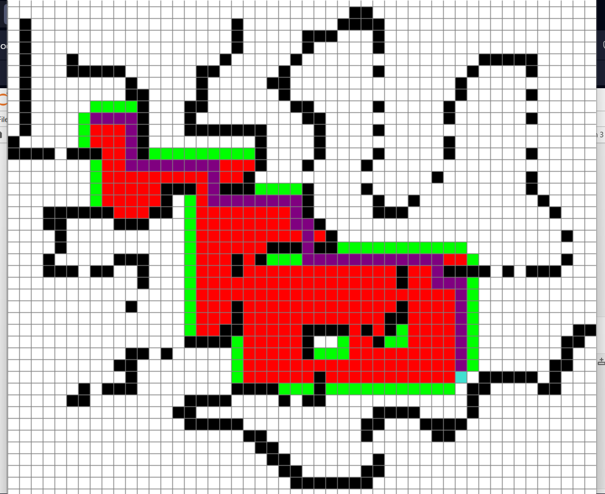

BFS:
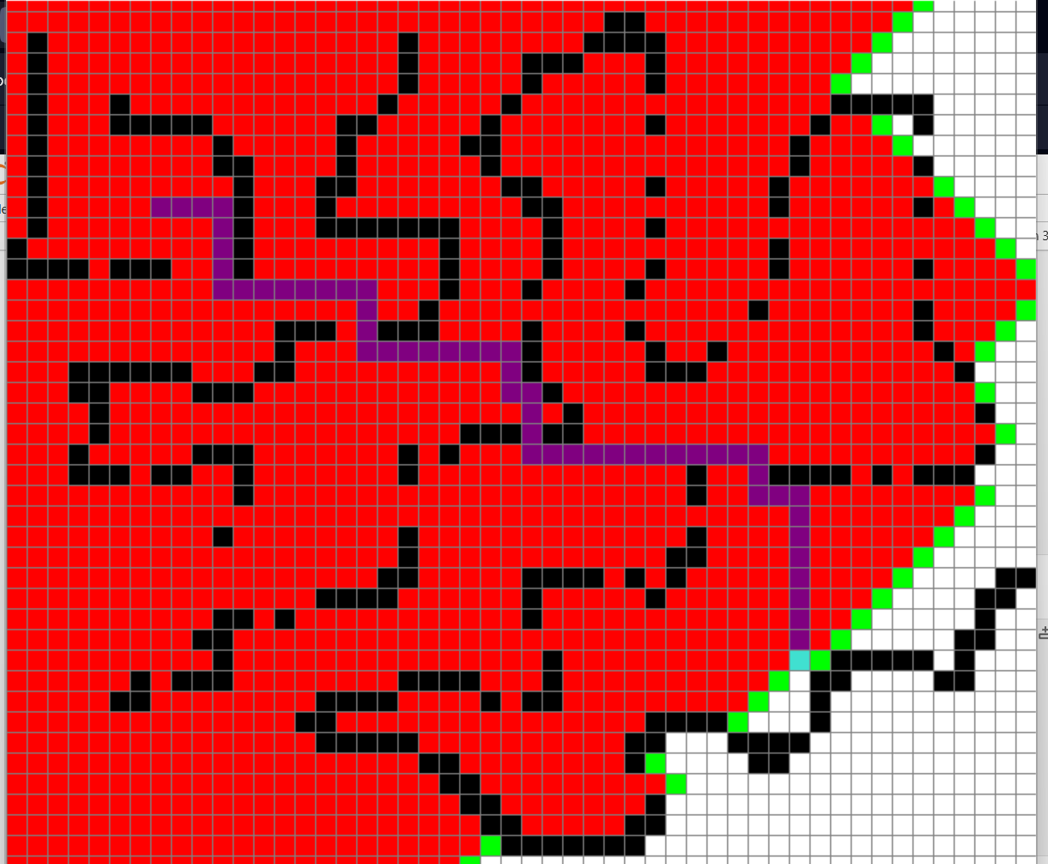

DFS:
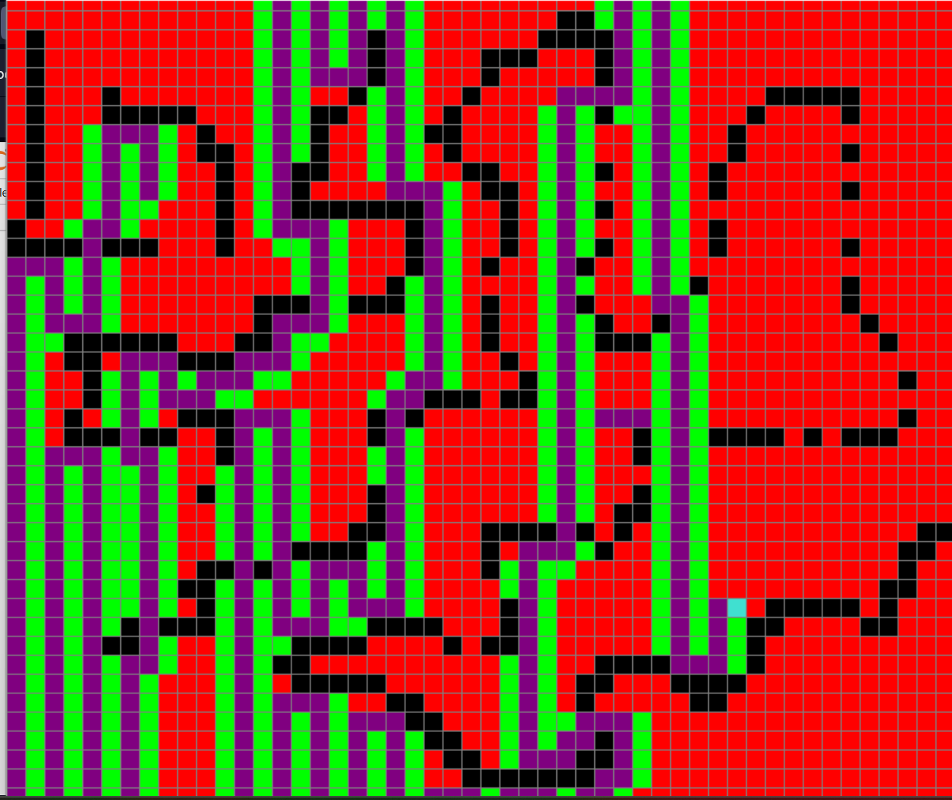

10. Conclusion
The Pathfinding Visualizer is an effective educational tool to demonstrate how pathfinding algorithms work. It enhances conceptual understanding by offering a hands-on, visual learning experience. The project can be further extended with more algorithms and features like diagonal movement, weighted paths, or dynamic environments.

11. Future Work
  - Add support for Dijkstra's Algorithm.
  - Enable diagonal and weighted path support.
  - Improve UI/UX with additional controls and animations.
  - Convert the application to a web-based interface using JavaScript and HTML5 Canvas.

12. References
- Pygame Documentation: https://www.pygame.org/docs/
- Pathfinding Algorithm Tutorials (GeeksforGeeks, YouTube, etc.)
- MIT OpenCourseWare on Artificial Intelligence

